

**I-9 Anywhere**

**Please use the following instructions to complete your Form I-9.**

* **Complete I-9 Form** 
  + **I-9 Form – Complete Part I**
  + **I-9 Form – Part II Schedule the appointment to have your ID’s verified**

**I-9 Form - You must complete Section 1 and electronically sign the I-9 form.  Section 2 is to schedule your appointment to have your ID’s verified.**

* Please complete the I9 through the following link:

<https://hrx.talx.com/ec/#/login/14229/Template/de237afb-17f6-4524-abea-a380cde206fa>

* + Select **Holy Cross Hospital-Florida** in the dropdown box – click Continue
  + You will be asked to provide 2 forms of ID – click Continue
  + Complete all of the * boxes – click Complete
  + Once all information has been entered you will be prompted to Review and Electronically sign the document (Sign with 2 initials)
  + Click the box then click Continue
  + **PLEASE PAY CLOSE ATTENTION AS YOU WILL NEED TO SELECT THE LINK TO SCHEDULE THE APPOINTMENT.** **IF YOU DO NOT SEE A LINK – PLEASE LOOK AT THE LEFT AND SELECT THE TASKS FOR THE APPOITNEMNT.  PLEASE FOLLOW THE ATTACHED JOB AIDE.**
  + You will be prompted to choose a location nearest you to schedule an appointment to have your Eligibility documents verified (Passport, Driver's License, State issued ID card, Birth Certificate, SSN card) THIS APPOINTMENT MUST BE COMPLETED PRIOR TO YOUR START DATE
  + You will receive a purple verification code – You DO NOT need to print this

Contents

Overview 3

Employer E-Verify Requirements: 3

Employer Document Policy 3

Appointment Scheduling 3

User Experience Testing 3

New Hire Experience 4

Canceling or Rescheduling an Appointment 8

# Overview

The I-9 Anywhere service uses Local Completer service providers to complete Section 2 of Form I-9. The following guide covers the new hire experience for scheduling Section 2 completion with a Local Completer, including steps to follow if an appointment needs to be cancelled or rescheduled.

# New Hire Experience

Schedule options will appear for the new hire after the completion of Section 1 of the Form I-9.

1. The new hire will begin the process by accessing their new hire packet. Once the I-9 is signed, the New Hire will begin the scheduling process:

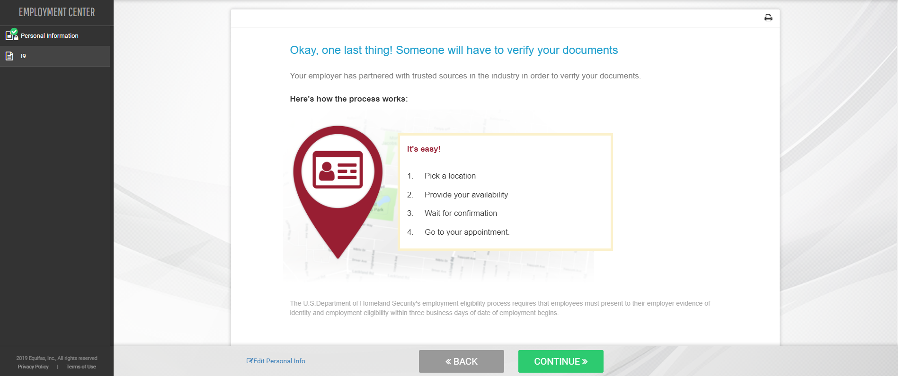

1. Location options will be presented based on the address the New Hire provided on the Personal Information Page. A new address can be entered in the search field to review different options.

The New Hire will select a location from the list of options to meet the Local Completer to finish his or her Form I-9.  
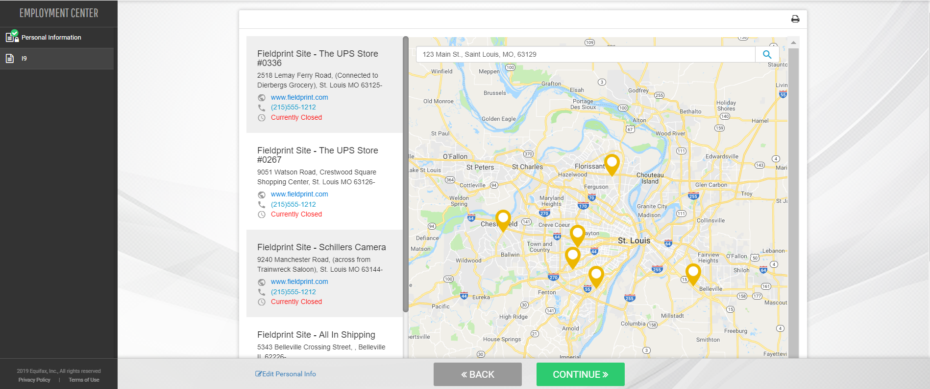

1. If a hire date was not provided by the Employer during the new hire packet creation the scheduling tool will require that an Employment Date be entered. Please provide this information to the New Hire so he or she knows the date to enter.

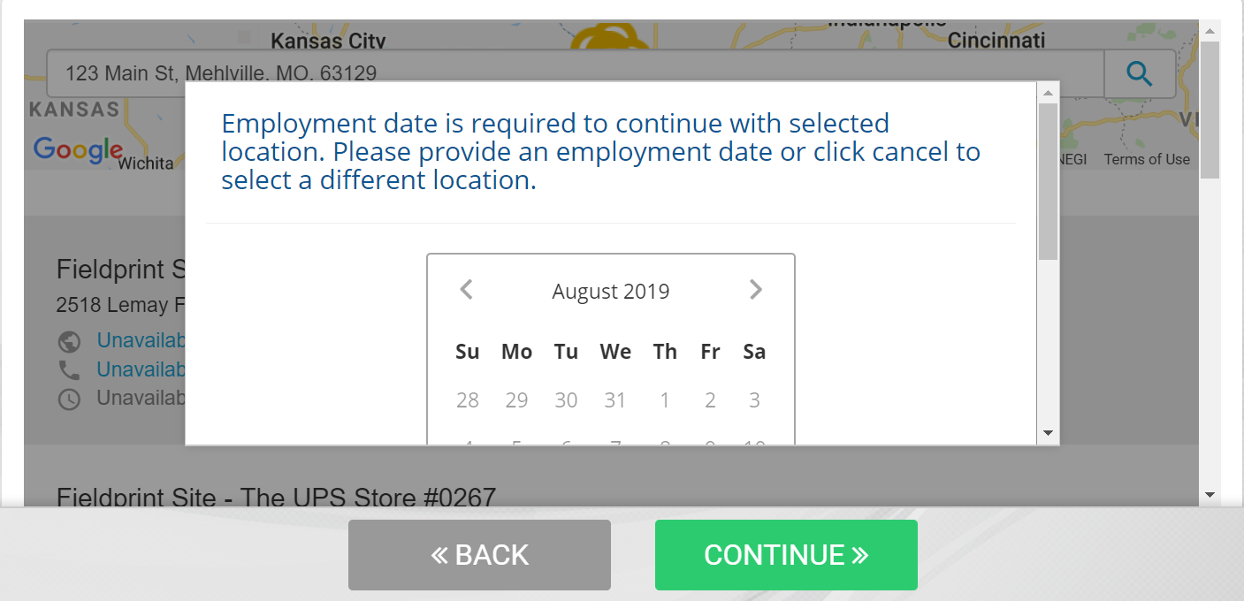

1. The New Hire will receive a map with the location’s address information. The New Hire will select a date and time for the appointment. **Once the New Hire clicks Continue, the appointment date and time will be confirmed.** To complete the scheduling process, the New Hire ***must* click Continue**.

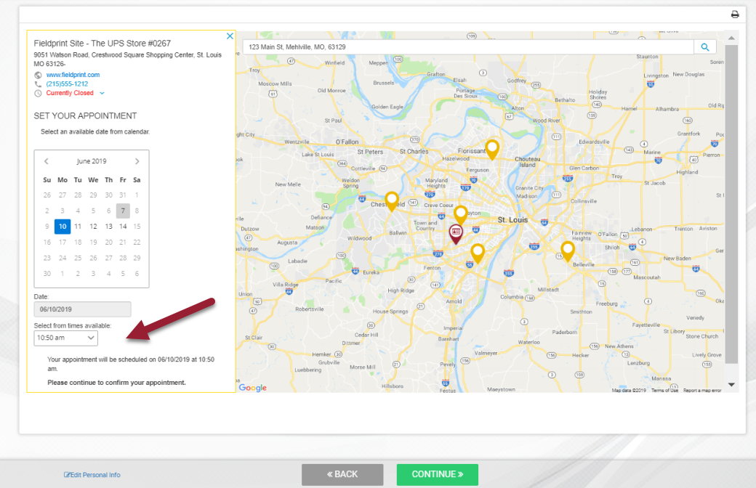

1. After clicking Continue, the New Hire is taken to the confirmation screen. The New Hire should print or email a copy of this confirmation page, since it has the appointment number the Local Completer will need to complete the Form I-9. This page will also provide a list of acceptable documents the new hire should bring to the appointment. The list is based on the citizenship status the New Hire elected in Section 1 of the Form I-9.

To complete the packet and scheduling process, the New Hire ***must* click Continue**.

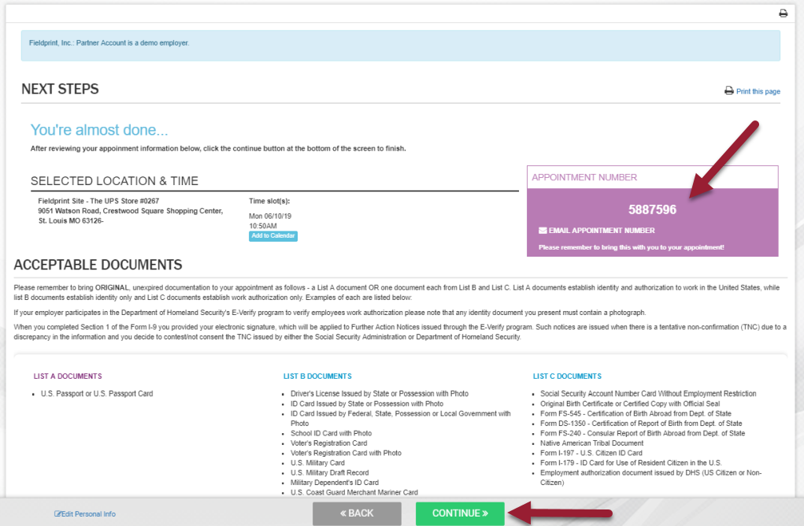

1. If the I-9 is the last document in the packet, the New Hire will see the Congratulations screen. The New Hire may logout or close the browser at this time.

If the New Hire has additional documents to review he or she will be able to continue completing the New Hire Packet.

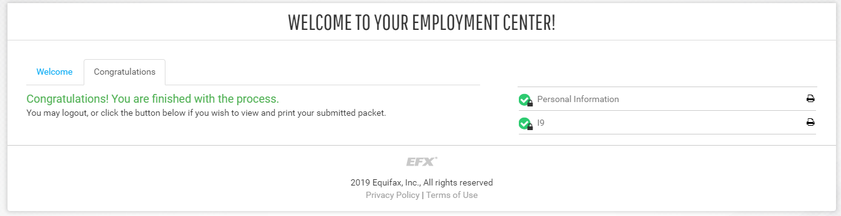

1. Shortly after completing the packet, the New Hire will receive an email confirming his or her appointment date, time, location, and appointment number.

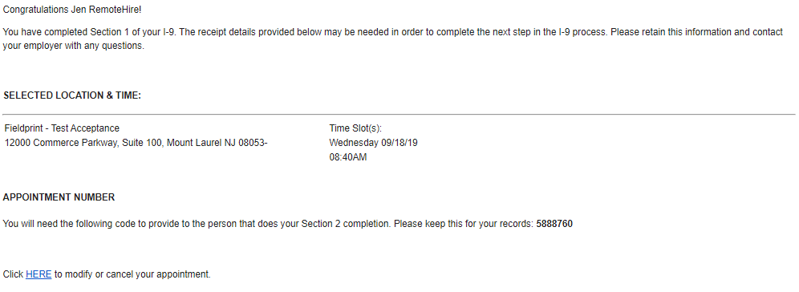

# Canceling or Rescheduling an Appointment

The information below describes the actions to follow should the employee need to cancel or reschedule the Section 2 completion appointment.

1. Upon clicking the link from the email to cancel or modify the appointment, the employee is presented with security challenge questions to populate, and will then click ‘Submit’. Then the employee will need to select either ‘Cancel Appointment’ or ‘Modify Appointment’.

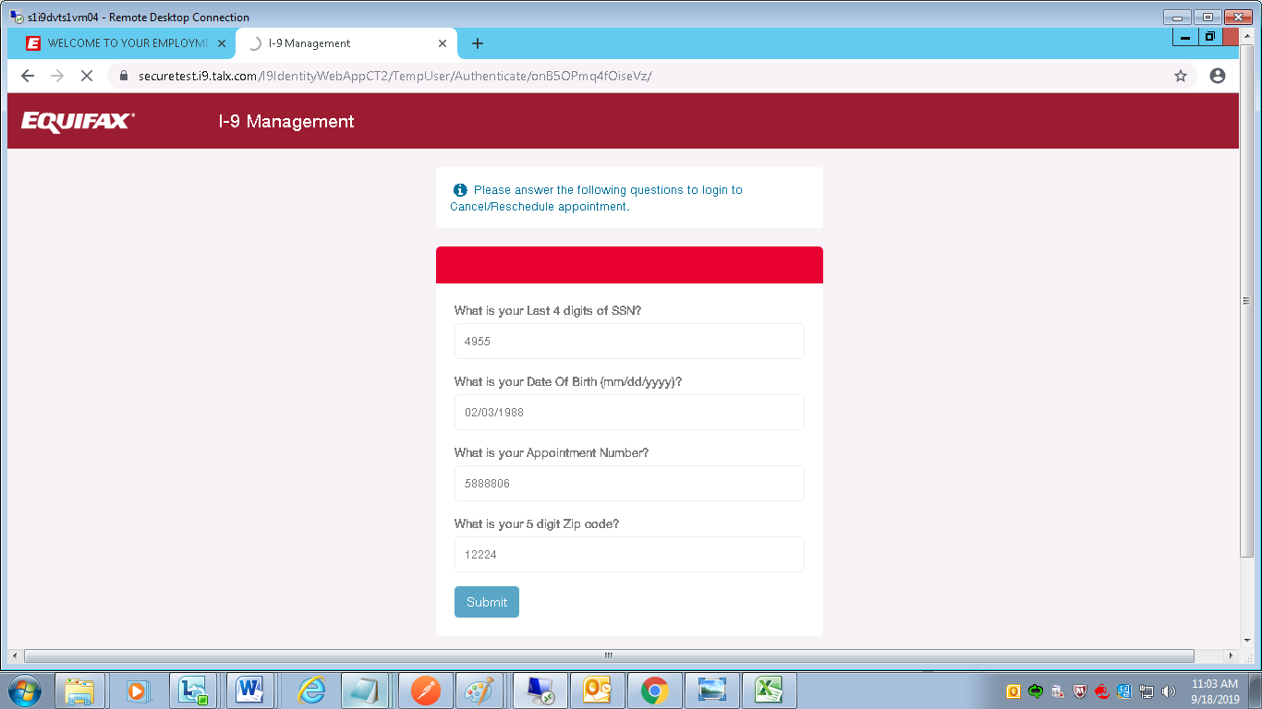

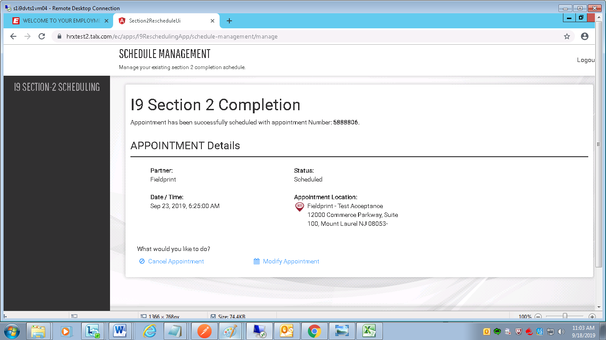

1. Should the employee choose to **cancel**, he or she would simply click ‘Cancel Appointment’ option and is then presented with a confirmation on screen.

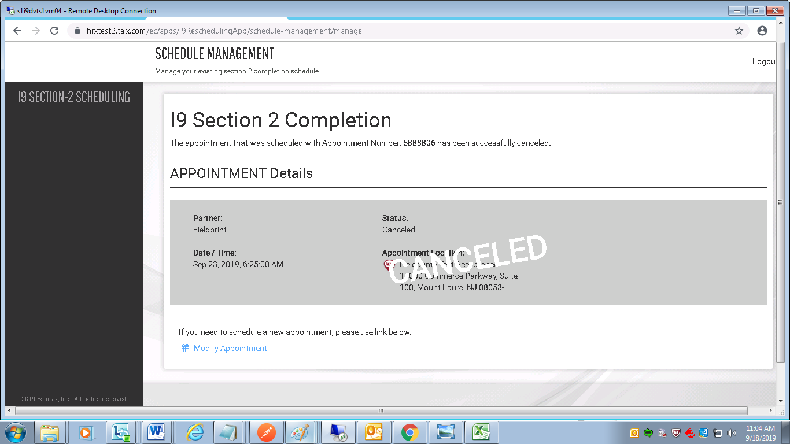

1. Should the employee choose to reschedule, he or she would choose ‘Modify Appointment’ to then choose a location and time, and then would receive appointment details for the newly scheduled appointment.

